**Assignment 3**

1) Write a program that demonstrates widening conversion from int to double and prints the result.

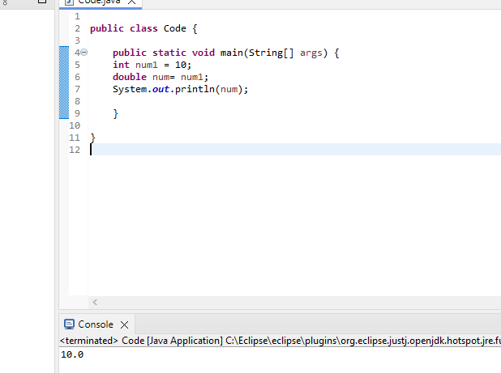

2) Create a program that demonstrates narrowing conversion from double to int and prints the result.

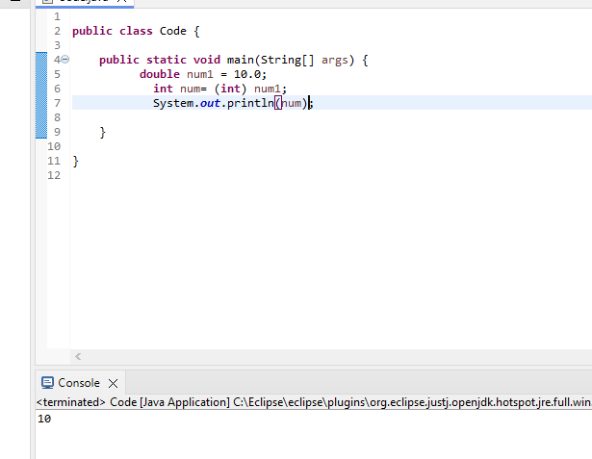

3 Write a program that performs arithmetic operations involving different data types (int, double, float) and observes how Java handles widening conversions automatically

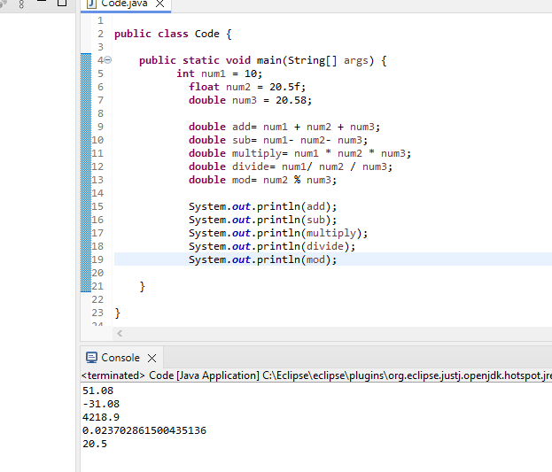

4) Write a Program that demonstrates widening conversion from int to (double,float, boolean, string) and prints the result.

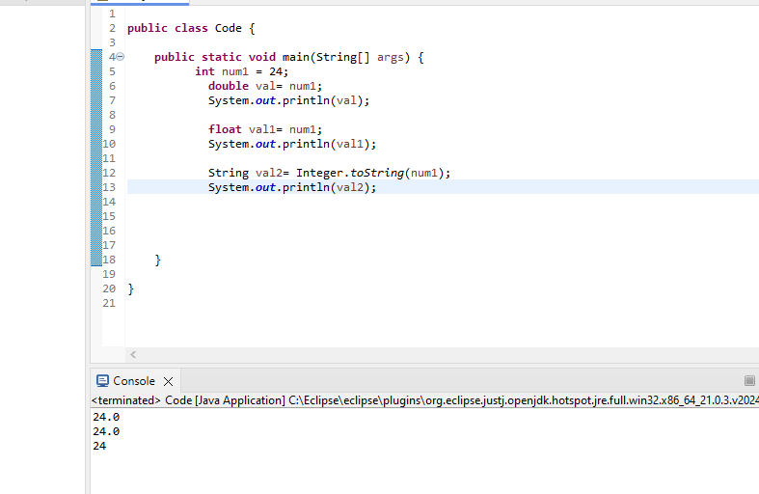

**Interview Questions**

1. **What does the static keyword mean in Java? Explain the difference between static and non-static methods.**

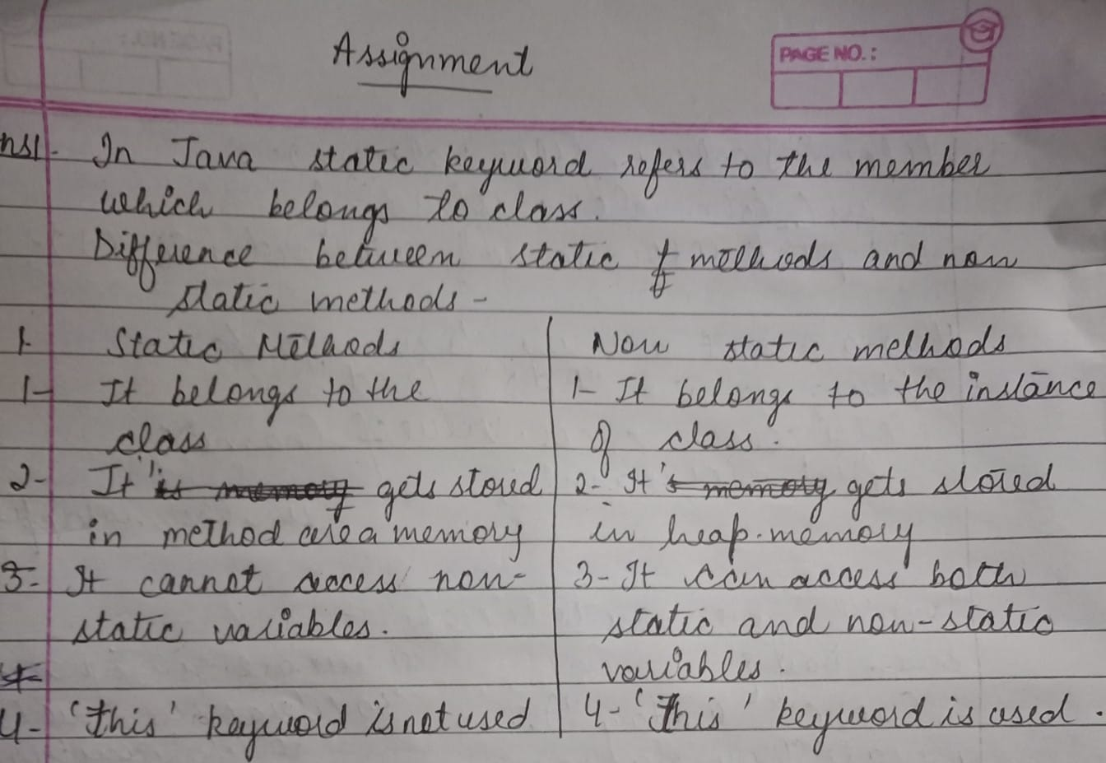

1. **What is the role of the static keyword in the context memory management.**

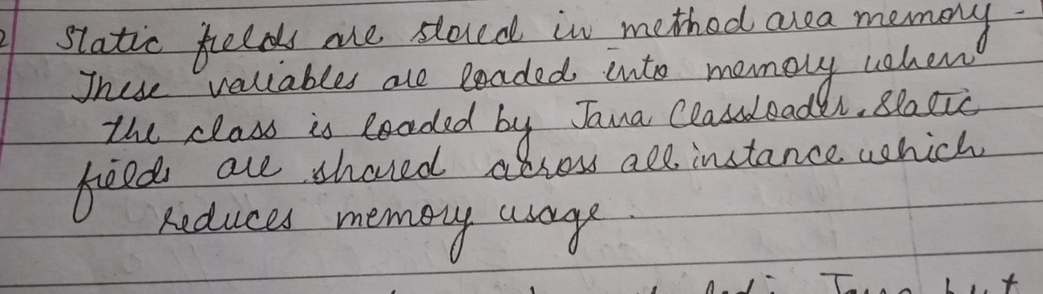

1. **Can static methods be overloaded and overridden in Java?Howstatic variables shared across multiple instances of a class?**

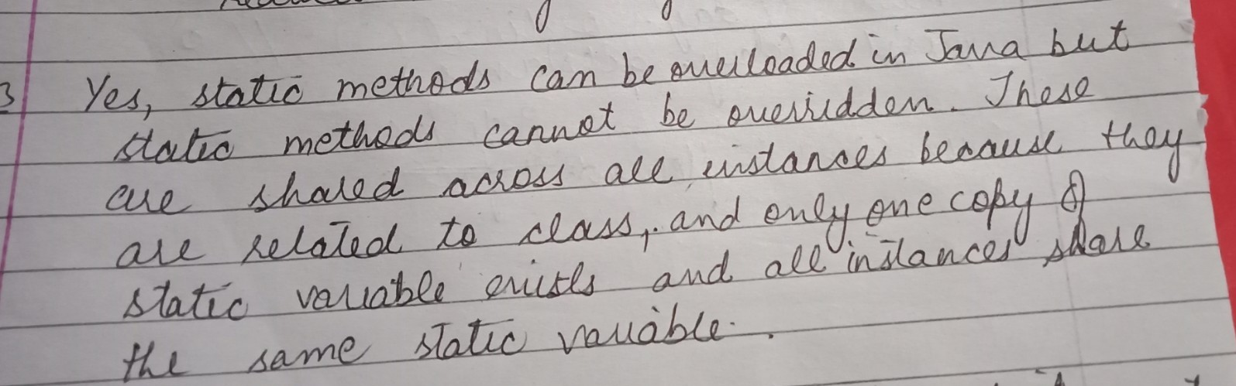

1. **What is the significance of the final keyword in Java?**

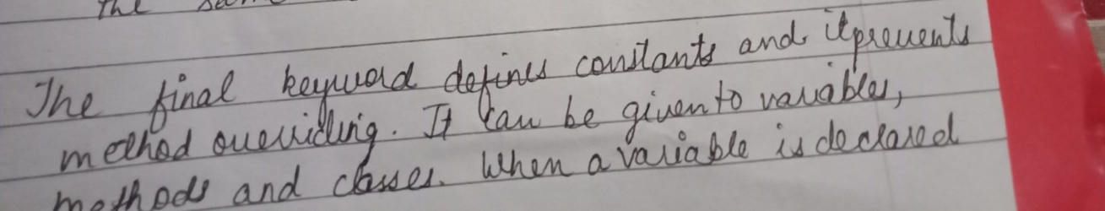

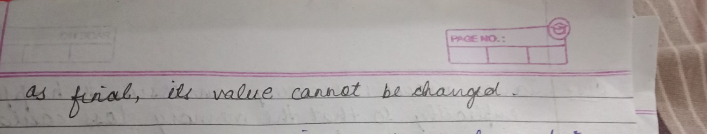

1. **What are narrowing and widening conversions in Java?**

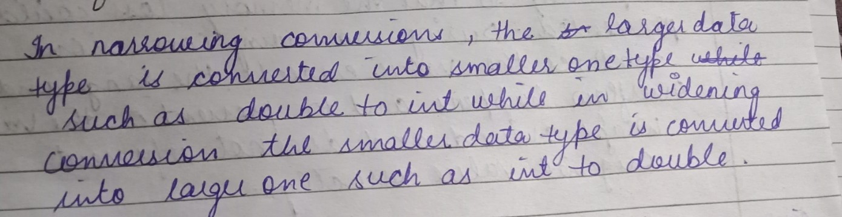

1. **Provide examples of narrowing and widening conversions between primitive data types.**

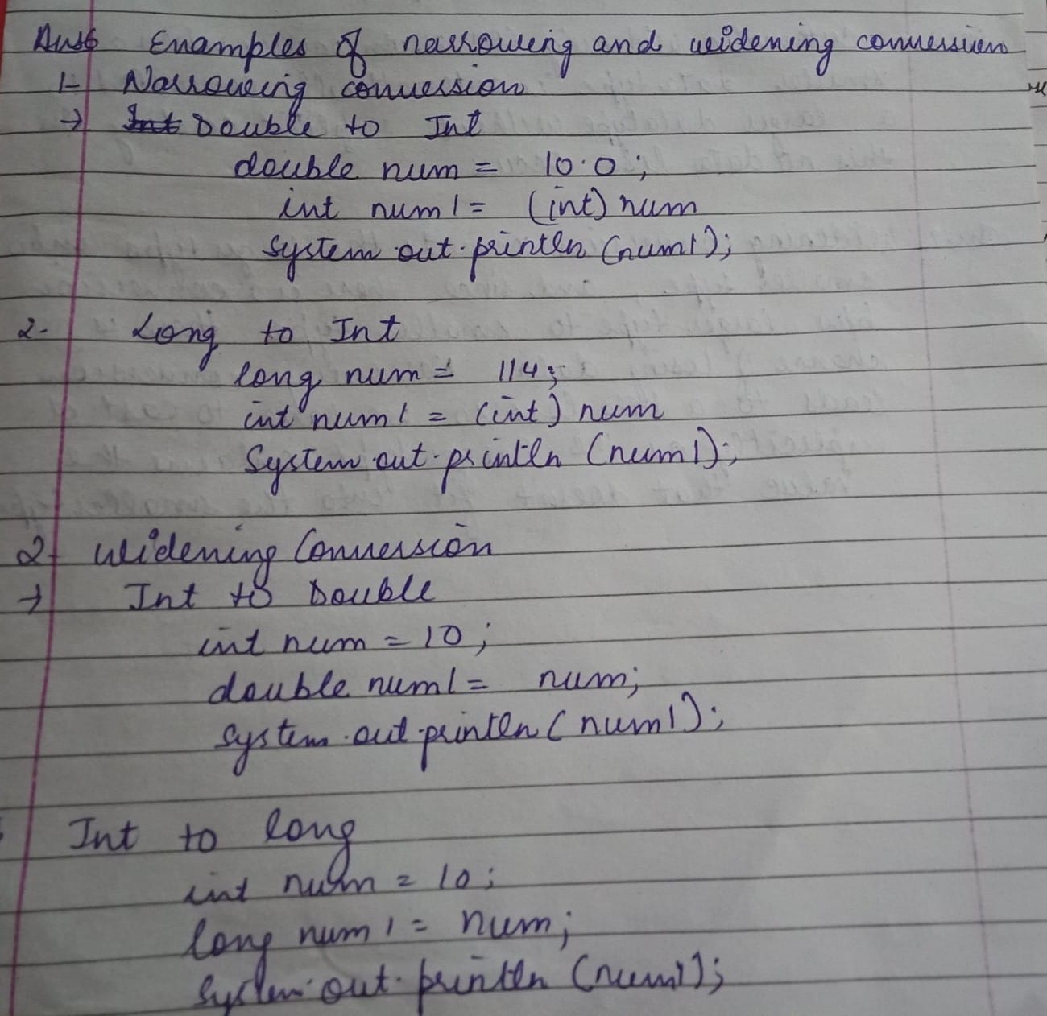

1. **How does Java handle potential loss of precision during narrowing conversions?**

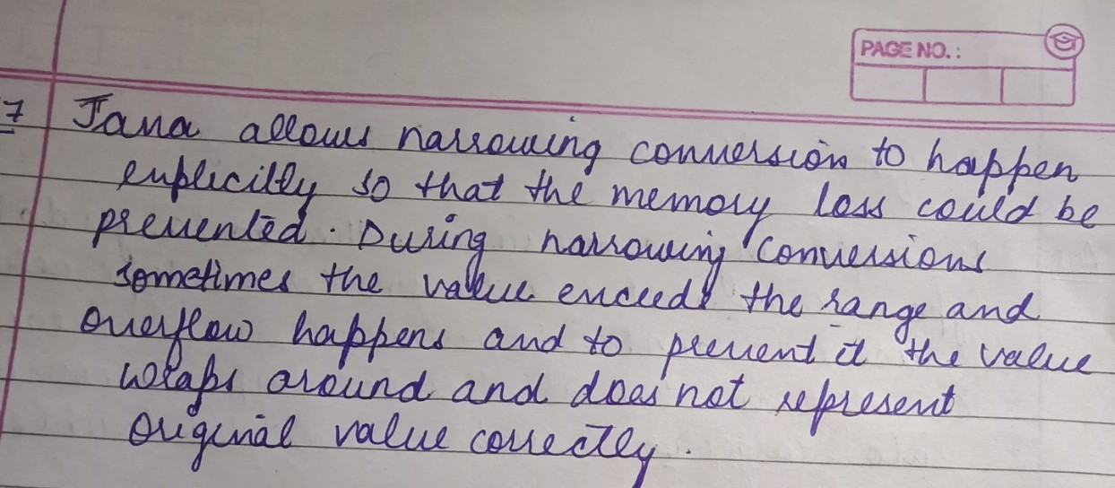

1. **Explain the concept of automatic widening conversion in Java.**

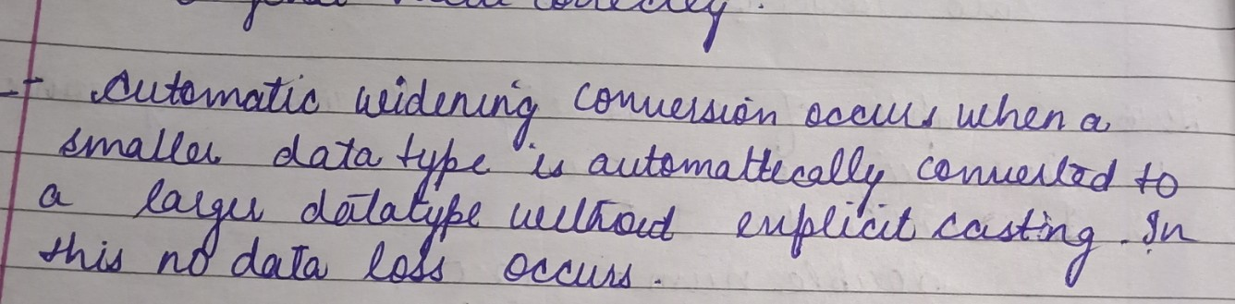

1. **What are the implications of narrowing and widening conversions on type compatibility and data loss?**

